This artifact is a continuation of the improvements made to the application written for IT-312, however in this case I’ve specifically targeted Algorithms and Data structure improvements in the form of the addition of an AI opponent. The inclusion of an AI combatant requires that the program be able to ‘understand’ the rules of the game and take actions that would have a reasonable chance of moving it toward victory.

To accomplish this, I added an AI method which is called on each AI participant’s turn, the program checks the current state, and determines the Ais next move. It will either roll all of the dice, re-roll some dice or accept the points it’s rolled. I think this has been very successful with the AI having a reasonable chance of winning.

The process of adding the AI to the solution was very informative. Since the GUI interface is user driven, I had to figure out a way for the AI to operate that wouldn’t just look like it didn’t do anything. I had a choice on how to resolve this issue, I could either spin the activities into a separate thread that would act independently. The other way, and what I opted to do, was to have the user step through the AIs turn, this would permit them to see all of the rolls.

Below are some images of the AI in action as well as code snippets for review.

AI’s first roll-

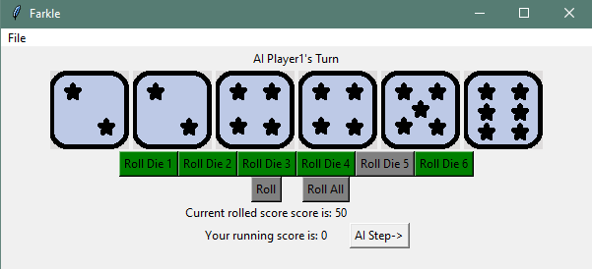

AI’s second roll-

